WELCOME TO ERCIYES UNIVERSITY
Erasmus Student Guide

Contents
MOBILITY STUDENTS 3
Erasmus+ for studies 3
Erasmus+ for traineeship 3
BEFORE MOBILITY 4
Applying for a visa 4
Accommodation 4
Check List 5
DURING MOBILITY 6
Completing the university registration procedures 6
Confirmation of Arrival 6
Learning Agreement 6
Course Registration 6
Sign Up & Setting Password for student e-mail 7
Obtain HES (Hayat Eve Sığar) Code 7
Tax Number 8
Buying a sim card 8
Transportation card 9
Registering your mobile phone 10
Residence permit application 10
Filling the residence permit application 10
Documents needed for the residence permit 12
Opening a bank account 13
Health services and health insurance requirements 13
AFTER MOBILITY 15
Confirmation of Stay 15
Transcript of Records 15
GENERAL INFORMATION 15
National and Religious Holidays 15
Cost of Life in Kayseri 16
Discover Turkey 17
Nation Wide Free Emergency Numbers 17
Discover Kayseri 17
Get to know our university 20
Turkish Language Courses 21

MOBILITY STUDENTS

Erasmus+ for studies
Erciyes University is a good choice if you want to enrich your educational path by spending a mobility period abroad. Erciyes University is pleased to welcome you.
The steps to be followed by the students who want to spend their mobility period at Erciyes University are described below:
- Check at your home University whether there is an agreement with the Erciyes University within your area of studies.
- Contact the International Relation Office/ Erasmus Office at your home university and make sure they nominate you for an exchange.
- Fill in the Learning Agreement for Studies and after your university signs it, send it by email to us together with the Transcript of Records and a copy of your Passport.

Erasmus+ for traineeship
Students interested in spending a mobility period at Erciyes University to carry out an internship within the Erasmus+ for Traineeship programme, need to send an email to the Erasmus Office of Erciyes University expressing the interest in conducting an internship at the University. Kindly note that you should be specific about the field of the internship you are interested in. We will get back to you as soon as possible with the decision on your internship.
Upon receipt of the confirmation from us, you need to fill the Learning Agreement for Traineeship which is the work plan agreed upon by you, your university and the tutoring professor at Erciyes University. After filling the document and signing it, send it to the International Office of Erciyes University by email.
As an exchange student for Traineeships you are not allowed to conduct exams and gain credits. On conclusion of your internship you will get your Certificate of Attendance. Your internship is certified by the supervisor of your activities by filling in the appropriate sections of the Learning Agreement for Traineeships.

BEFORE MOBILITY

Applying for a visa
If your country is not exempted from visa by the Republic of Turkey, you are required to have a visa to enter Turkey. To learn about the visa regime applied by Turkey to your country, please check the website of the Ministry of Foreign Affairs‎.
To apply for a student visa, you are required to visit the nearest Turkish Embassy or Consulate in your country with the following documents:
- Acceptance Letter from Erciyes University
- A completed visa application form
- The Visa fees
- Passport and passport sized pictures
(Please check here if there are any more requirements from the responsible consulate)
We advise you to apply at least two months before the semester begins, so that you don’t face any delay and be ready for the semester.

Accommodation
There are several accommodation options available for international students: staying in a private dormitory close to campus or sharing an apartment with Turkish students. For those students that choose private accommodation near campus, it is just a short bus ride or within walking distance.
Female students can stay at the university dorm. (Melikgazi Yurdu) For details, you should contact Erasmus Office or your coordinator to book a place at the dorm.
There are many accommodation options available in Kayseri. You can choose between private dormitories or rented flats. You can find more information on private dormitories here. Additionally, there are many websites where you can search for rented flats such as Emlakjet and Sahibinden. You can also choose to share the flat with other students. Rental conditions vary from owner to owner and, as such, make sure to ask all the pertinent questions (contract duration, internet access, amenities, and services included). Please be careful not to pay anything before seeing the flat.
If you need help in finding accommodation, the International Office representatives are happy to assist you.

Check List
Prepare your trip. Confirm:
- That you are carrying your identification document/ Passport with you (pay attention to the validity period).
- That you have a valid visa
- That you have the acceptance letter from Erciyes University
- That you have enough cash that can easily be converted into Turkish Lira as credit cards may not be accepted everywhere and to avoid paying heavy conversion fees from the banks.
- That you have a place to stay in Kayseri for the first few days in case you do not yet have housing.
- That your university's International Relations/ Erasmus Office sent over the following documents:
- Application form
- Academic Record
- Study plan signed by you and your coordinator.
- That your university's International Relations/ Erasmus Office informed Erciyes University of the day of your arrival.

DURING MOBILITY
You have made it here, that is what matters. Do not worry, the rest is easy!

Completing the university registration procedures

Confirmation of Arrival
Some Home Universities require the confirmation of arrival. The document is provided by your home institution. It will be signed at the beginning of your studies at the Erciyes University. If you are not sure whether your institution requires such a document, please contact the IRO/Erasmus Office at your home University.

Learning Agreement
Within the first month of your exchange, you should prepare your Learning Agreement “During the mobility” (part 2) in case there are any changes to your courses. Any courses you will not attend should be removed or replaced with those you have chosen to attend.

Course Registration
The course registration (course selection) procedures of mobility students who are just enrolled are carried out by the supervisors of the departments they have enrolled. For the course registration, you can log in with student numbers and passwords on our university Student Information System (OBİSİS) and view course schedules and advisors.
(https://obisis.erciyes.edu.tr/)

Sign Up & Setting Password for student e-mail
Students who will use their institutive e-mail account for the first time will be able to set their first passwords with the login code they will request to their GSM numbers registered in the Student Information System (OBISIS), and renew their passwords with the same method when they forget their passwords.
From the internet browsers, students can access the interface by entering this address: https://posta.erciyes.edu.tr.
Entering their email address consisting of a 10- digit student number (ten-digitstudentnumber@erciyes.edu.tr) and entering their GSM numbers registered in the Student Information System (OBISIS), they will receive a SMS login code. After receiving the SMS login code, the first password can be set. Students can access their e-mail accounts at https://webmail.erciyes.edu.tr.
E-mail users who want to change their GSM numbers registered in the system, enter the address (https://posta.erciyes.edu.tr ) in the web browser, then click on the mobile phone number update link to save the GSM number in the system by using own e-mail address and existing password.

Tax Number
To obtain health insurance, register your phone, and for many other issues, you will need a Turkish tax number, therefore it is recommended to get one as soon as possible. You can get your temporary tax number from the Vergi Dairesi (Tax Office). All you need is your passport and a photocopy of the passport page with your photograph on it.

Buying a sim card
You can choose between the available operators in Turkey such as Turkcell, Türk Telekom, or Vodafone. The companies have different advantages, you can check the campaigns and prices and decide which operator you would like. You should get your mobile phone and passport with you when you get to the store. You can purchase a sim card with your passport but remember that the sim will get blocked within 90 days if you do not register your residence permit with it. To register your residence permit, you can go to any shop of your operator, and ask them to associate your residence permit number with your sim card.

Transportation card
Transportation in Kayseri is quite active and easy. The transportation within the city relies mainly on buses, the Light Rail Transit (LRT) system called Kayseray, taxis and personal vehicles.
You can purchase a transportation card, which is valid for busses and railway, at any KART38 cabin or office which are available in the whole city. The card costs approximately 10 TL and you can recharge it through the Kart38 Machines. You just need to put your card on the scanner on the left and put your money into the slot. One fare with a normal card is 7,00 TL, but for students, the price is 3.25 TL. You can make one free transfer during your journey within 80 minutes. You can check the fare prices and apply online for a student card here or you can apply to the Kayseri Metropolitan Municipality PASO and Card Unit to benefit from discounted services within the city.
Documents required for application:
- Residence document for foreign students
- Student ID
- Copy of the passport
- 1 Passport photo (taken within last 6 months)
(https://www.kayseri.bel.tr/pasolar-ve-kartlar)
On the Official Website of Kayseri Ulaşım, you can find detailed information about the transportation in Kayseri such as bus services and timings, bicycle renting, buying transportation card and recharging points, etc.

Registering your mobile phone
According to Turkish law, A mobile phone, which is bought from abroad, must be registered. Otherwise, your phone will be blocked, and you will not be able to use it in Turkey. You have 120 days to register your phone. In case you do not want to register your phone, you can buy a simple phone in Turkey.
- Buy a Turkish SIM Card from Vodafone, Türk Telekom, or Turkcell.
- Register your phone by taking your passport and IMEI number (you can check it on your phone by dialling *#06#). Pay the fee at the Tax Office (fee is subject to change).
- Submit the tax payment receipt to the phone provider you purchased the SIM from.

Residence permit application
Make the application for the residence permit (ikamet) within 30 days of your arrival. You must do your online application before your visa/residence permit expires in order to avoid paying any fine.
Erasmus+ students and interns as well as other exchange program students are required to apply for the short-term residence permit. The reason for the stay should be chosen as Student Exchange Program.
The application for the residence permit must be done online at https://e-ikamet.goc.gov.tr/. Please keep in mind that when you start the online application you should have: a digital biometric photo (you can check the legal requirements of the photo here), health insurance, and passport.

Filling the residence permit application
- Choose your type of application:
- If you are a new student and you are applying for residence permit for the first time, you must choose the pink coloured for the first-time application.
- If you already have a residence permit and it is about to expire, then you should choose the green coloured application for the extension of the duration of the residence permit.
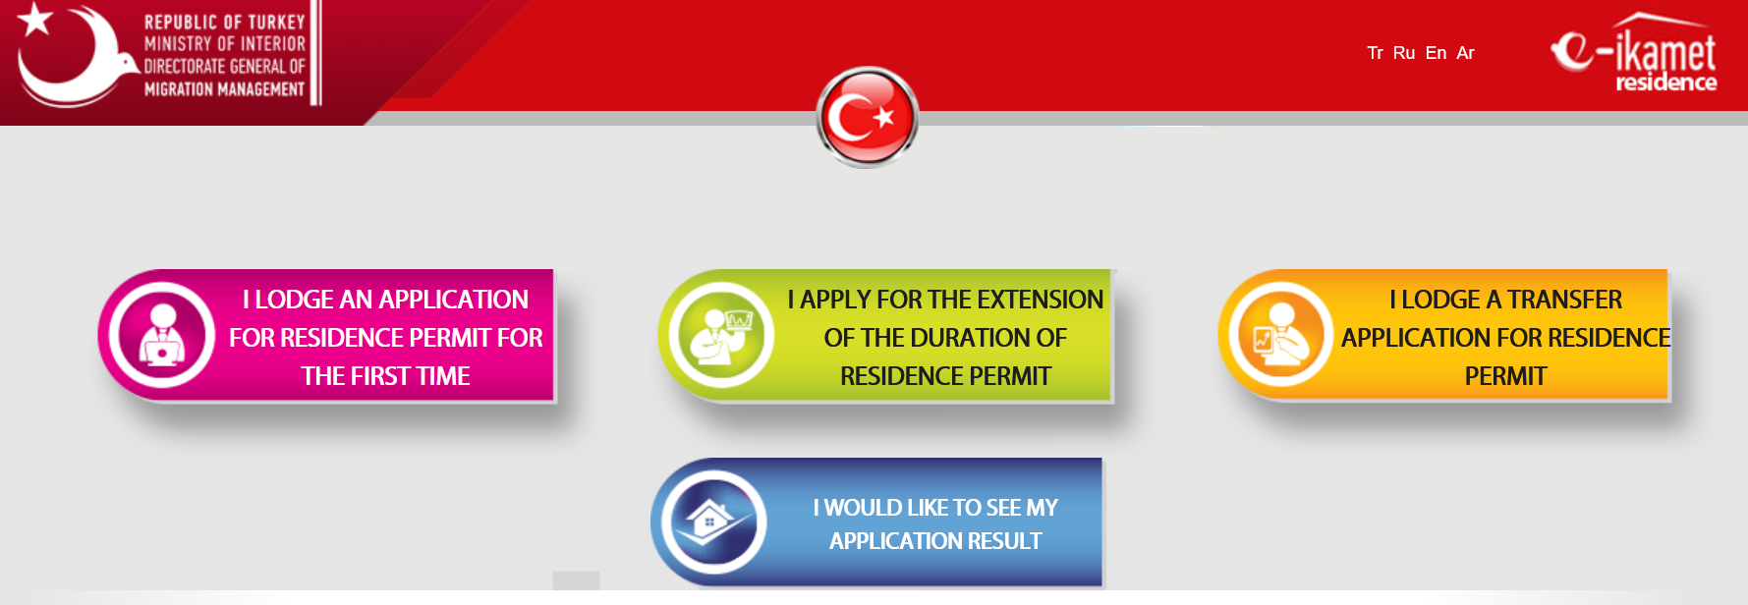
- Next, you must click “I would like to lodge a new application” or if you already started the application you can continue by clicking on the second option.
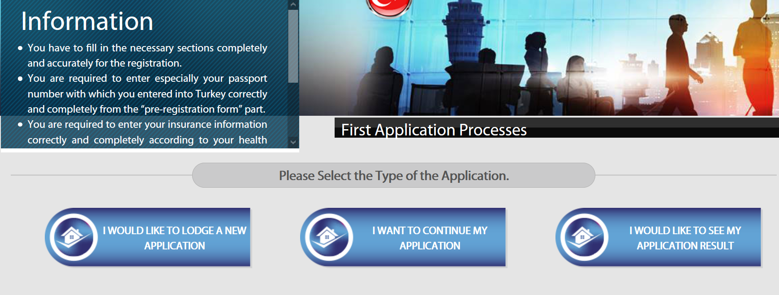
- The pre-registration screen will show up to get your verification code and application number. The fields in the red colour are mandatory to fill in whereas the fields in grey are optional. Fill in ‎your information and click save. ‎You will receive a text message or e-mail from GOC IDARESI.
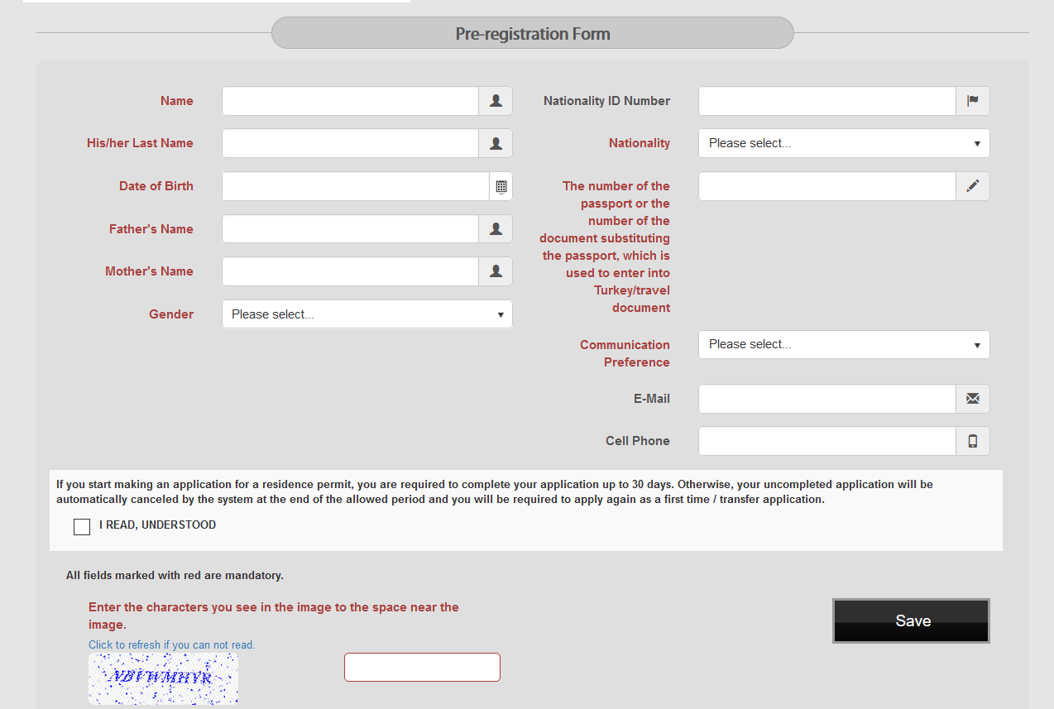

Documents needed for the residence permit
After you complete your online application for the residence permit, you will have an appointed day to submit the necessary documents. You need to present the below documents at the Kayseri Goç Idaresi.
- Passport
- Four biometric photos
- Photocopy of passport
- Photocopy of the old residence permit (if you have one)
- Student certificate in Turkish (You can take it from the International Office)
- Payment of fee receipt (Can be paid at Kayseri Vergi Dairesi- Vezneler)
- A printout of your online application form (signed)
- Health insurance policy (should be valid for one-year minimum)
- E-visa printout (for the students who have one)
- Accommodation proof
- In cases where the student is under the age of 18 and is arriving without a visa:
  - Deed of consent (Muvafakatname)
  - Birth certificate (Turkish translation - notary approved)
- Students who enter Turkey with a visa (student visa or e-visa etc) should not pay the fee for the visa. However, the students who are exempt from visa requirements for entering Turkey should pay the visa fee to the tax office, to take residence permits. They should submit the original receipt to start the necessary procedure for the issuance of the residence permits.
NOTE: All the fees can be paid at Kayseri Vergi Dairesi at Vezneler (Pay-office) which is located on the first floor of the building.

Opening a bank account
You may face difficulties opening a bank account without a residence permit. Therefore, it is preferred to first apply for the residence permit.
To open a bank account, you will need the following documents:
- Residence permit
- Passport
- Turkish Tax number
- Address in Turkey
Do not forget that you need to be over 18 years old to open a bank account in Turkey. An associate at the bank will supply you with all the necessary forms to open a Turkish bank account. Fill out the proper authorization forms. The bank will send your ATM card to your address.

Health services and health insurance requirements
If you have public health insurance from any of the countries mentioned below you will be exempted from Health Insurance in Turkey. You should contact your public insurance office and you should receive the forms arranged with your name and details.
Example:
If you are from Germany and you have public insurance, please contact the health insurance office and ask them for T/A 11 formula. They will arrange for you a paper with your name and the dates you will stay in Turkey. Please do not forget to get an official stamp and signature from the insurance office. You should bring this paper with you to Turkey.
Country citizens listed below can use this option:
- Albania AL/TR 4, TR/AL 5
- Austria A/TR 3, A/TR 4
- Belgium BT.8, BT 16
- Bosnia-Herzegovina BH/TR 4, BH/TR 6, BH/TR 7
- France SE 208-01 FT, SE 208-02 FT SE 208-30 FT, SE 208-06 A FT, SE 208-28 FT, SE 208-09 FT
- Germany T/A 11, T/A 9, T/A 20,
- Luxembourg TR/L 3, TR/L 5
- Macedonia MC/TR 4, TR/MC 6
- Romania R/TR 3, R/TR5, R/TR 6
- The Czech Republic CZ/TR 111
- The Netherlands N/TUR 106, N/TUR 111, N/TUR 121
- Turkish Republic of Northern Cyprus K.K.T.C/T.C. 3, K.K.T.C/T.C. 6
Healthcare in Turkey consists of a mix of public and private health services. Having health insurance is compulsory for all international students of Erciyes University. International students have two options for getting health insurance in Turkey.
- Kayseri Provincial Directorate of Social Security (SGK): http://www.sgk.gov.tr/wps/portal/sgk/en/home-page/mainpage
- It can also be done through any Private Insurance companies.
After deciding on the company, you can visit one of their offices to buy health insurance or ‎request it online. Please make sure to express that you need the insurance for ‎the residence permit in Turkey so that the insurance is conforming to the requirements. ‎
Can foreign students benefit from health services?
Foreign students should apply personally to the nearest social security centre in order to benefit from general health insurance.
- Foreigners who have obtained a residence permit in Turkey.
- Foreigners who do not have health insurance in any country except for Turkey.
- Foreigners who have lived for over a year and have applied after that time can benefit from general health insurance.
How to get service from public hospitals, university hospitals and doctors with private examination?
Students who need to get service from public or university hospitals can apply to health institutions with their residence permit or passport provided that they have compulsory health insurance. Students who have insurance get healthcare in public or university hospitals without any additional payment.
In addition, some doctors have private clinics. Since they have their wage scale, the service from these doctors is typically not covered by health insurance plans. For this reason, getting healthcare service from the doctors who have private clinics can be financially compeller.

AFTER MOBILITY

Confirmation of Stay
This is one of the most important documents of Erasmus. It indicates the dates that the student was enrolled at our university. You may collect the document at our office.

Transcript of Records
You can require the Transcript of Records if you are a Mobility student for studies. The traineeship mobility students will not receive such document as they don’t undertake exams.

GENERAL INFORMATION

National and Religious Holidays
There are two types of public holidays in Turkey: the religious holidays which change according to the lunar calendar and fall on different dates each year; and those which are decided by the government and fall on the same day each year. Please remember that, on public holidays, banks and government offices are closed.
National Holidays:
1 January - New Year’s Day
23 April - National Sovereignty and Children’s Day
1 May – Labour Day
19 May - Atatürk Commemoration, Youth and Sports Day
15 July - Democracy and National Unity Day
30 August - Victory Day
29 October - Republic Day
Religious holidays:
Eid-ul-Fitr: Three days religious holiday.
Eid al-Adha: Four days religious holiday.

Cost of Life in Kayseri
The average cost of living in Kayseri varies from the way the students spend. To have an idea of the cost of life in Kayseri, please see the below table.
Student Transport card | 3.25 TL
Private Housing | 2000-5000 TL (depending on the choice)
Dormitories | 2000 TL
Bread | Starting from 3.5 TL
Simit | 5 TL
Student menu at ERU | 11 TL
Tea | 5 TL
Bottle of water | 3 TL
Coffee | 20 TL
Chicken | 50 TL
Meat | 150 TL
Fish | 70 TL
McDonald Menu | 60 TL

Discover Turkey
Turkey is a country of in depth history and culture, the Turkish Republic is located where the three continents of the old world, Asia, Africa and Europe, are closest to each other and straddle the point where Europe and Asia meet. Because of this geographical location, the mainland Anatolia has witnessed the mass migration of diverse peoples, shaping the course of history. Home to countless civilizations, Anatolia has developed a unique synthesis of cultures, each with its own distinct identity, yet each linked to its predecessors through insoluble threads. As a modern nation in an ancient land, Turkey today is the inheritor and conservator of such an essential, shared heritage of humanity.

Nation Wide Free Emergency Numbers
110- Fire Department
112- Medical Emergency (Ambulance)
154- Traffic
155- Police
157- Foreigners Communication Centre

Discover Kayseri
Kayseri, located in Central Anatolia, has a great historical background dating back to 3000 BC. Kültepe, one of the first cities in Anatolia and a critical route of Assyrian trade colonies, was established by Hattis, the local people of Anatolia before Hittites. Assyrians had founded commercial posts called “karum” by 2000 BC. One of the most important karums was the Kaneš in Kültepe. The cuneiform clay tablets found in Kültepe really reveal about the history of trade in Kayseri. The city was under Roman rule in 17 AD. This period was known as "Caesarea in Cappadocia" named in honour of Caesar Augustus . When the Arabs arrived the city, they called the city as “Kaisariyah” as a result of adapting the pronunciation to their writing. However, during the Seljuk rule, it eventually became “Kayseri”. During the strong reign of the Seljuks, the trade routes were revived and developed.
The first Turkish-Islamic campus in Anatolia was the Hunat Hatun Complex which was constructed in honour of Hunat Hatun in 1276 and includes a mosque, madrasa, baths and a soup kitchen. In the period of the Anatolian Seljuks, a large number of historical works of art such as mosques, madrasas and in particular the monumental tomb, called the “Turning Vault”, were constructed and have survived to the present day. The historical Covered- Bazaar, which is the third largest in our country, still serves as a shopping centre in Kayseri. Kayseri Castle, the Turning Vault, and the ancient volcano Mount Erciyes are the main historical and natural symbols of Kayseri.
The first aircraft and textile industries in our country began in Kayseri. Kayseri is also famous for its hand-woven silk and wool carpets, soudjouk & pastrami, and manti (a ravioli-like dish served with yoghurt). The city has a population of over one million. The city consists of 16 metropolitan districts. Erkilet International Airport is a short distance from the city center. The city is also connected to the rest of the country with railway service. The transportation within the city depends mainly on buses, personal vehicles and light rail transit. There are 2 new generation post-modern sport venues. One is Kadir Has Stadium, which has the capacity of 33,000 spectators. The other is Kadir Has Sports Arena, which has a seating capacity of 7,200 people. There are 3 state and 1 private universities in the city. The state ones are Erciyes University, the first and the largest one; Abdullah Gul University, started enrolling students in 2013; Kayseri University, a newly-established one. Nuh Naci Yazgan is a private university founded in 2009. In addition, Kayseri is an industrialized city with a lot of various factories and companies in Kayseri Free Zone. The city was one of the first trade fair sites in the world. The Kaneš and Karum ruins, centres of trade between the Assyrians and the Hittites, are 22 kilometres to the east of Kayseri’s Foreign Bazaar, which itself belongs to the Seljuk period and lies 80 kilometres to the south-east of Kayseri.
Besides possessing a great number of relics and ancient remains from the Hittite, Assyrian, Greek and Roman periods, the city also has a great number of Ottoman and Seljuk historical works of art and has always been a trade centre as well. A great many large historical inns and caravanserais exist in its vicinity and several of them are still spectacular places to visit. The Sultan Han, 45 kilometres to the east of Kayseri, the Karatay Caravanserai, 60 kilometres south-east of Kayseri, and Incesu Kara Mustafa Pasha Caravanserai, 20 kilometres west of Kayseri, are among the few that still exist.
Mt. Erciyes, located at height of 1800-3000m and 25 km away from the city center, is one of the most attractive winter tourism centers in Turkey. Anatolian Wonderland, with a zoo within its body, is situated on an area of 180 decares. There are a lot of recreational activities to do as well such as ice skating, figure skating, and ice hockey etc. Mount Ali, one of the most important paragliding centers in our country, has characteristics of an international center for paragliding.
Cappadocia is a famous tourist destination located in the southwest of Kayseri. It has many areas with unique geological, historic, and cultural features.
The Toros Mountains, which lie within the borders of the city, the Kapuzbashi Waterfalls near Yahyalı and Sultan Sazlighi (bulrushes), also known as “Birds’ Paradise'' on the same route, are among the area’s natural wonders. Millions of birds, including 259 varieties, fly over or visit Sultan Sazligi every year. Kayseri, the centre of the Cappadocia region, is 80 kilometres from Göreme and 70 kilometres from the Soğanlı Valley, a picturesque valley of innumerable chapels, church halls, houses and tombs.
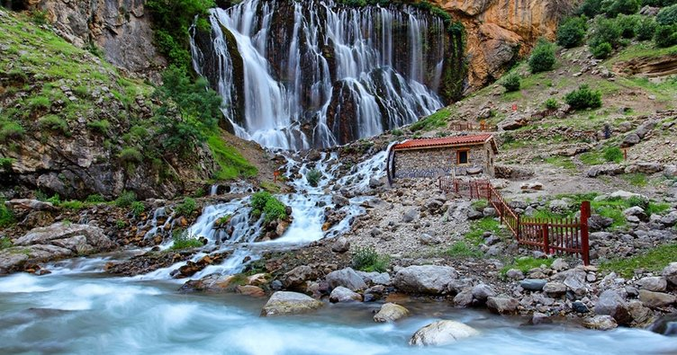
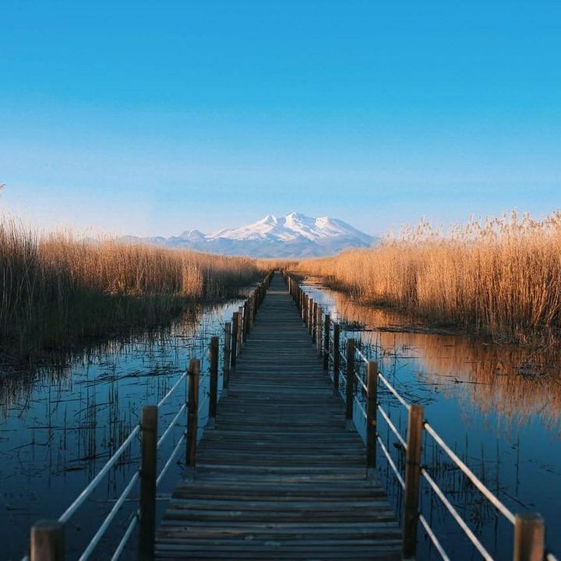

Get to know our university
Erciyes University which is located in Kayseri province in the Central Anatolia Region of Turkey was established in 1978. The name of the University was inspired by Mount Erciyes (3916 m), which lies 15 kilometers to the southwest of the city. Mt Erciyes is one of Turkey's most influential winter sports centers.
Today, Erciyes University is among the most reputable universities of Turkey and consists of 7 institutes, 18 faculties, 3 colleges, 10 vocational colleges, 38 research centers. Erciyes University has 3 campuses (Kayseri Central, Seyrani & Tomarza) and a total of 445 departments. The main campus (Kayseri Central Campus) has integrating education, research and health services all in one area.
The university has Medicine, Engineering, Economics and Administrative Sciences, Architecture, Dentistry, Veterinary Medicine, Theology, Fine Arts, Education, Communication, Sciences, Arts, Health Sciences, Aeronautics and Astronautics, Tourism, Law, Pharmacy, Agriculture faculties. A highly developed research hospital consists of more than 1,500 beds with a general hospital (Gevher Nesibe Hospital) and with its other hospitals is among the most influential health facilities in the region.
Our students and staff have the opportunity to benefit from the specific national & international Exchange Programs working under our Foreign Relations Office such as Erasmus+, Mevlana & Farabi exchange programs.
Erciyes University has 140 student clubs operating under 10 platforms (Health, Economics and Business Administration Platform, Science and Culture, Culture and Art, Science, Technology, Social Activities, Sports, Education and Literature & Theatre Platforms).
Please refer to the Information Catalogue for more detailed information about the faculties, schools, vocational schools, graduate schools, and research centres of ERU.

Turkish Language Courses
The International Students who wish to learn Turkish can apply to ERSEM (Erciyes University Continuing Education Center).
Did you know that Turkish is…
- spoken natively in two continents but only one country.
The largest Turkish-speaking city, Istanbul, has a population of 14 million. Istanbul is unique in that it spans two continents: half of it is in Europe, and the other half is in Asia. There are approximately 10 million native Turkish speakers in Europe and just under 70 million in Asia.
- Spoken more than Italian and Greek combined.
There are 60 million native Turkish speakers throughout the world and 15 million more who speak it as a second language. So altogether that are over 75 million people on the planet who know Turkish.
- Turkish words are essentially sentences.
As Turkish is an agglutinative language, complex phrases are formed by adding prefixes and suffixes instead of adding different words. For example, the word evlerinizden means “from your houses”, and consists of four individual parts: ev (house), ler (plural), iniz (your), and den (from).

Please confirm if these are all the documents needed and if the procedure described is correct.
Course registration, information about the student e-mail as well as some information below is from the ERU International Student Guide
If there is available data regarding this, I would like to add an approximate number of the International Students and the number of countries they come from.
Other universities offer free native language courses for the incoming Mobility students. Because I could not find any information related to this, I didn’t add more information. If ERU offers free Turkish classes, we can add that information too.

